Stormwater Maze
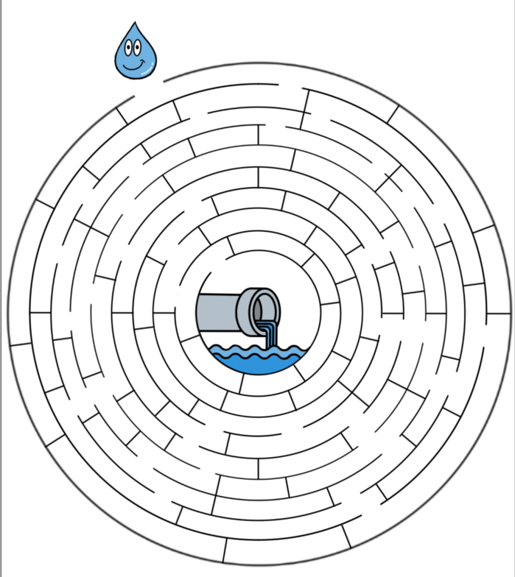
Directions: Help the rain get down the drain! Guide the raindrop through the maze until it reaches the river. Make sure not to pick up any trash along the way!

